Name=Leela jayashree

Trainer=Harshee pitroda

Course=python and ML

Date=3/6/22

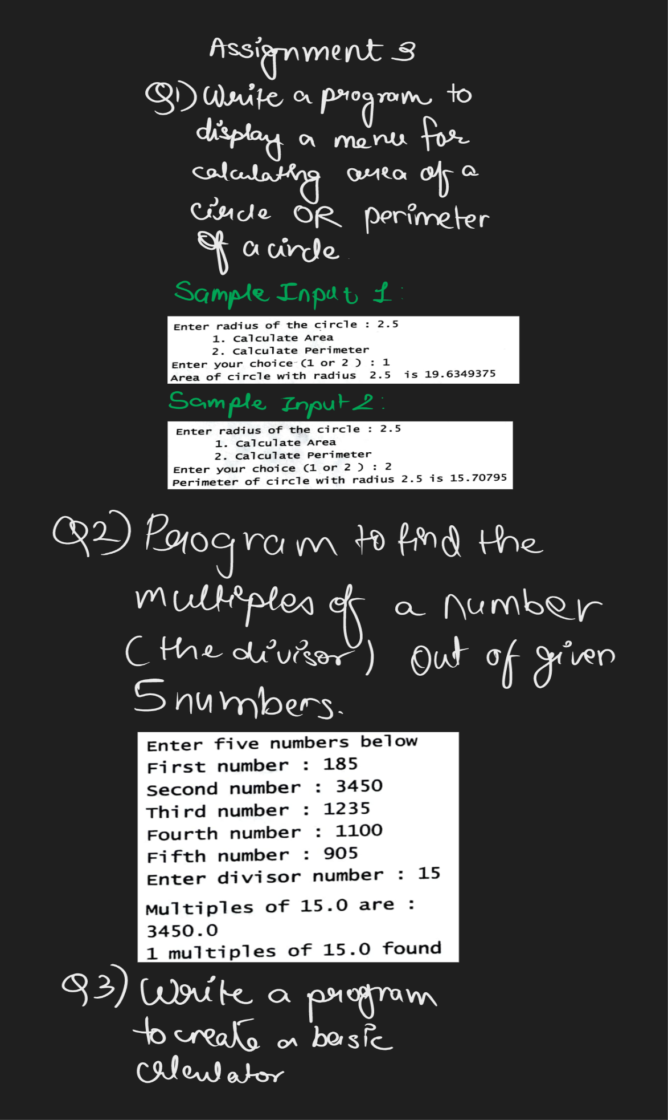

**Q1)** radius=float(input("enter the radius of the circle: "))

area_of_the_circle=3.14*radius**2

perimeter_of_the_circle=3.14*radius*2

choice=int(input('enter your choice(1 or 2):'))

if choice==1:

print("The area of the circle is:", area_of_the_circle)

if choice==2:

print("the perimeter of the circle is:",perimeter_of_the_circle)

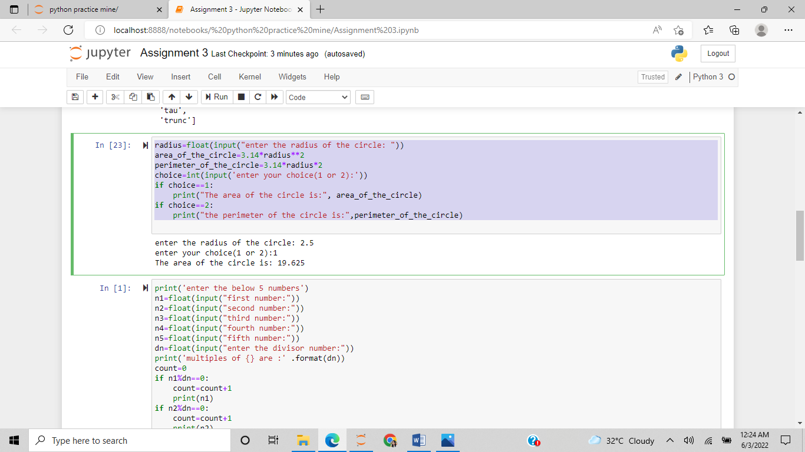

Q2) print('enter the below 5 numbers')

n1=float(input("first number:"))

n2=float(input("second number:"))

n3=float(input("third number:"))

n4=float(input("fourth number:"))

n5=float(input("fifth number:"))

dn=float(input("enter the divisor number:"))

print('multiples of {} are :' .format(dn))

count=0

if n1%dn==0:

count=count+1

print(n1)

if n2%dn==0:

count=count+1

print(n2)

if n3%dn==0:

count=count+1

print(n3)

if n4%dn==0:

count=count+1

print(n4)

if n5%dn==0:

count=count+1

print(n5)

print('{} multiples of {} are found' .format(count,dn))

print('end program')

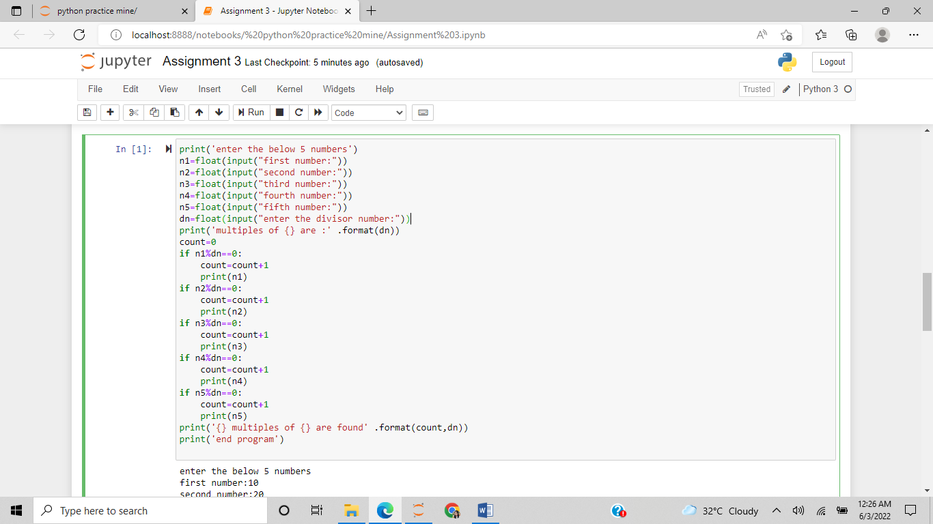

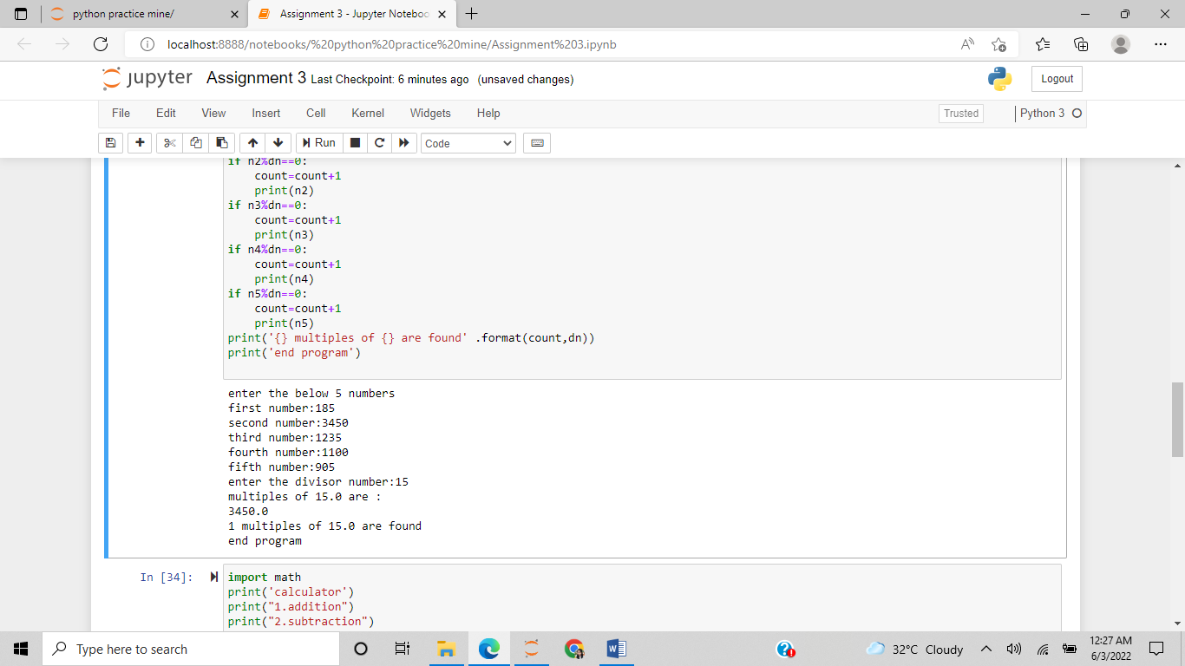

Q3) import math

print('calculator')

print("1.addition")

print("2.subtraction")

print("3.multiplication")

print("4.division")

print("5.square root")

print("6.factorial")

print("7.modulus")

print("8.floor")

print("9.tan")

print("10.sin")

choice=int(input("enter your choice:"))

n1=float(input('enter first number:'))

n2=float(input('enter second number:'))

if (choice==1):

print(n1, "+",n2, "=",(n1+n2))

elif choice==2:

print(n1, "-", n2, "=",(n1-n2))

elif choice==3:

print(n1,"*",n2,"=",(n1*n2))

elif choice==4:

if n2==0:

print('division with 0 error')

else:

print(n1, "/" ,n2, "=",(n1/n2))

elif choice==5:

print(n1, "**", n2, "=",(n1**n2))

elif choice==6:

print(math.factorial(n1),math.factorial(n2))

elif choice==7:

print(n1, "%" ,n2, "=",(n1%n2))

elif choice==8:

print(n1, "//" ,n2, "=",(n1//n2))

elif choice==9:

print(math.tan(n1),math.tan(n2))

elif choice==10:

print(math.sin(n1),math.sin(n2))

else:

print('requested function not available')

